Week 6 Individual Logbook
Capstone project
Matt Baker
2026
Table of Contents
Hours Breakdown 2
Completed Content/Documentation 3
Team Meetings 3
Advisor Meetings 3
Client Meetings 3
Research 4
Documentation 4
Testing 5
Development 8

Hours Breakdown
Category | Hours completed
Team meetings
Client meetings
Advisor meetings
Research
Development
Testing
Documentation
Logbook preparation | 1 hr
Sick leave/specific conditions
Other
Total Hours for this week
Running total of hours completed for  Capstone | 0/450hrs

Completed Content/Documentation

Team Meetings
Monday, August 17
11:15M-12AM (45 mins)
Reviewing the feedback on the initial project proposal, then discussing, delegating work for its improvement.
Tuesday, August 18
10:15-11:30AM (1hr 15 mins)
Regular team meeting discussing work done to complete the proposal, organize other meetings, complete auditing, and discussing a necessity for specificity in the document, as well as a good explanation on the type of AI we are using and how.
Wednesday, August 19
5:00PM-6:00PM (1hr)
Debrief after the meeting with Bryce, the type of reports, discussing work to be done, adjusting the roles, difference between methodology/method, AI working with nMap. Refining our list of tools to 3.

Advisor Meetings
Monday, August 17
2:00PM-2:30PM (30 mins)
Meeting with Dr Dax Roberts, we need more content in our proposal, we need to clearly describe each tool and what it does, including Ollama, and describe the core of our project, how it involves AI. I also continued to produce my list of AI tools and added more columns.
Wednesday, August 19
4:00PM-5:00PM (1hr)
We spoke to Bryce functioning as a consultant, who shared plenty of wisdom regarding his previous efforts of using AI with Nmap, that we need to choose a new methodology, his opinions on our roles, technologies we’ve selected, and that we need to reduce our workload while expanding our scope, suggests OneNote for documenting log hours.

Client Meetings
Friday, August 21
10:00AM – 10:45 (45 mins)
Whole team present we had a meeting with Geoff, I discussed with him permission and possibility to nmap scan the soit network, brought him up to date on our communications with Bryce and adjustment of scope, we discussed his preference to ownership that being a split ownership. We also discussed the preference and differences between ollama and lmstudio, particularly the ease of interaction and support of LLM models. We discussed some interfacing software for “agentifying” the processes completed in tools like exiftool and foremost into natural language-queryable reports like “deepseek harness, unsloth, and openwebui. We also had him assist us in ssh connecting to the PC to fix an issue with multiple RDC logins preventing access to the PC.

Research

Documentation
Monday, August 17
1:00-1:45PM (45 mins)
Formatting the project proposal, producing some statements for a layman about the nature of the project, the distinction between the two types of AI tools that exist, a definition of file carving, and
Tuesday, August 18
5:30-7:00PM (1hr 30 mins)
Finding and documenting all of the working versions of the tools we are testing for the proposal.
Wednesday, August 19
10:00AM – 1:00PM (3 hours)
Refining the project proposal, editing some poor or unclear language. Adding statements describing specifically the categories of “AI” and what the nature of the existing tools are. A background to generative AI, adding and improving scope statements, as well as the client section.
1:00PM – 2PM (1 hr)
Producing an agenda/questions/points of discussion in preparation for our meeting with Bryce
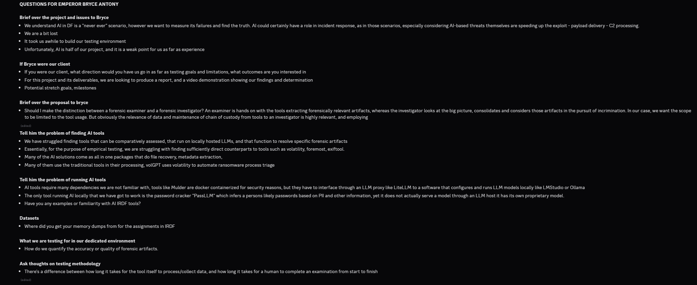

Thursday, August 20
3:15-9:30PM (6 hrs 15 mins)
Based on Bryce’s feedback from our meeting on Wednesday, Sam and I were in real time referring to the recording of this meeting, I was discussing each point with him to clarify what our interpretation of his comments were, and then importing these changes to the best of my ability into the new evolution of the proposal document. These points being topics like the new methodology “Design science” the distinction between “methods vs methodologies”, and the driven down definition of our process identifying the root cause of an incident and generating a report on it. I adjust the scope statements related to the definitions of digital forensics and incident response to reflect the priority and definition Bryce provided for these. Added labels to severity and likelihood levels. Adjusted the descriptions of the roles to a more realistic scope. I also weighed up and edited what we could afford to remove, the most ideal selection of 3 tools, and whether we can just leave 4 tools in. I discussed with sam whether nmap is classed as a “digital forensics software”, and if we need to ask for permission to scan the weltec network or whether virtual network scanning resources will suffice to simulate. I also continued to write my definitions of LLMs and how they fit into the context of our project.
Friday, August 21
1:00PM – 1:30 (30mins)
In the proposal, I added captions that cross reference each table, as well as a statement on appendix A and B.

Testing
Monday, August 17
3:00-4:00 (1hr)
Got Sherloq running
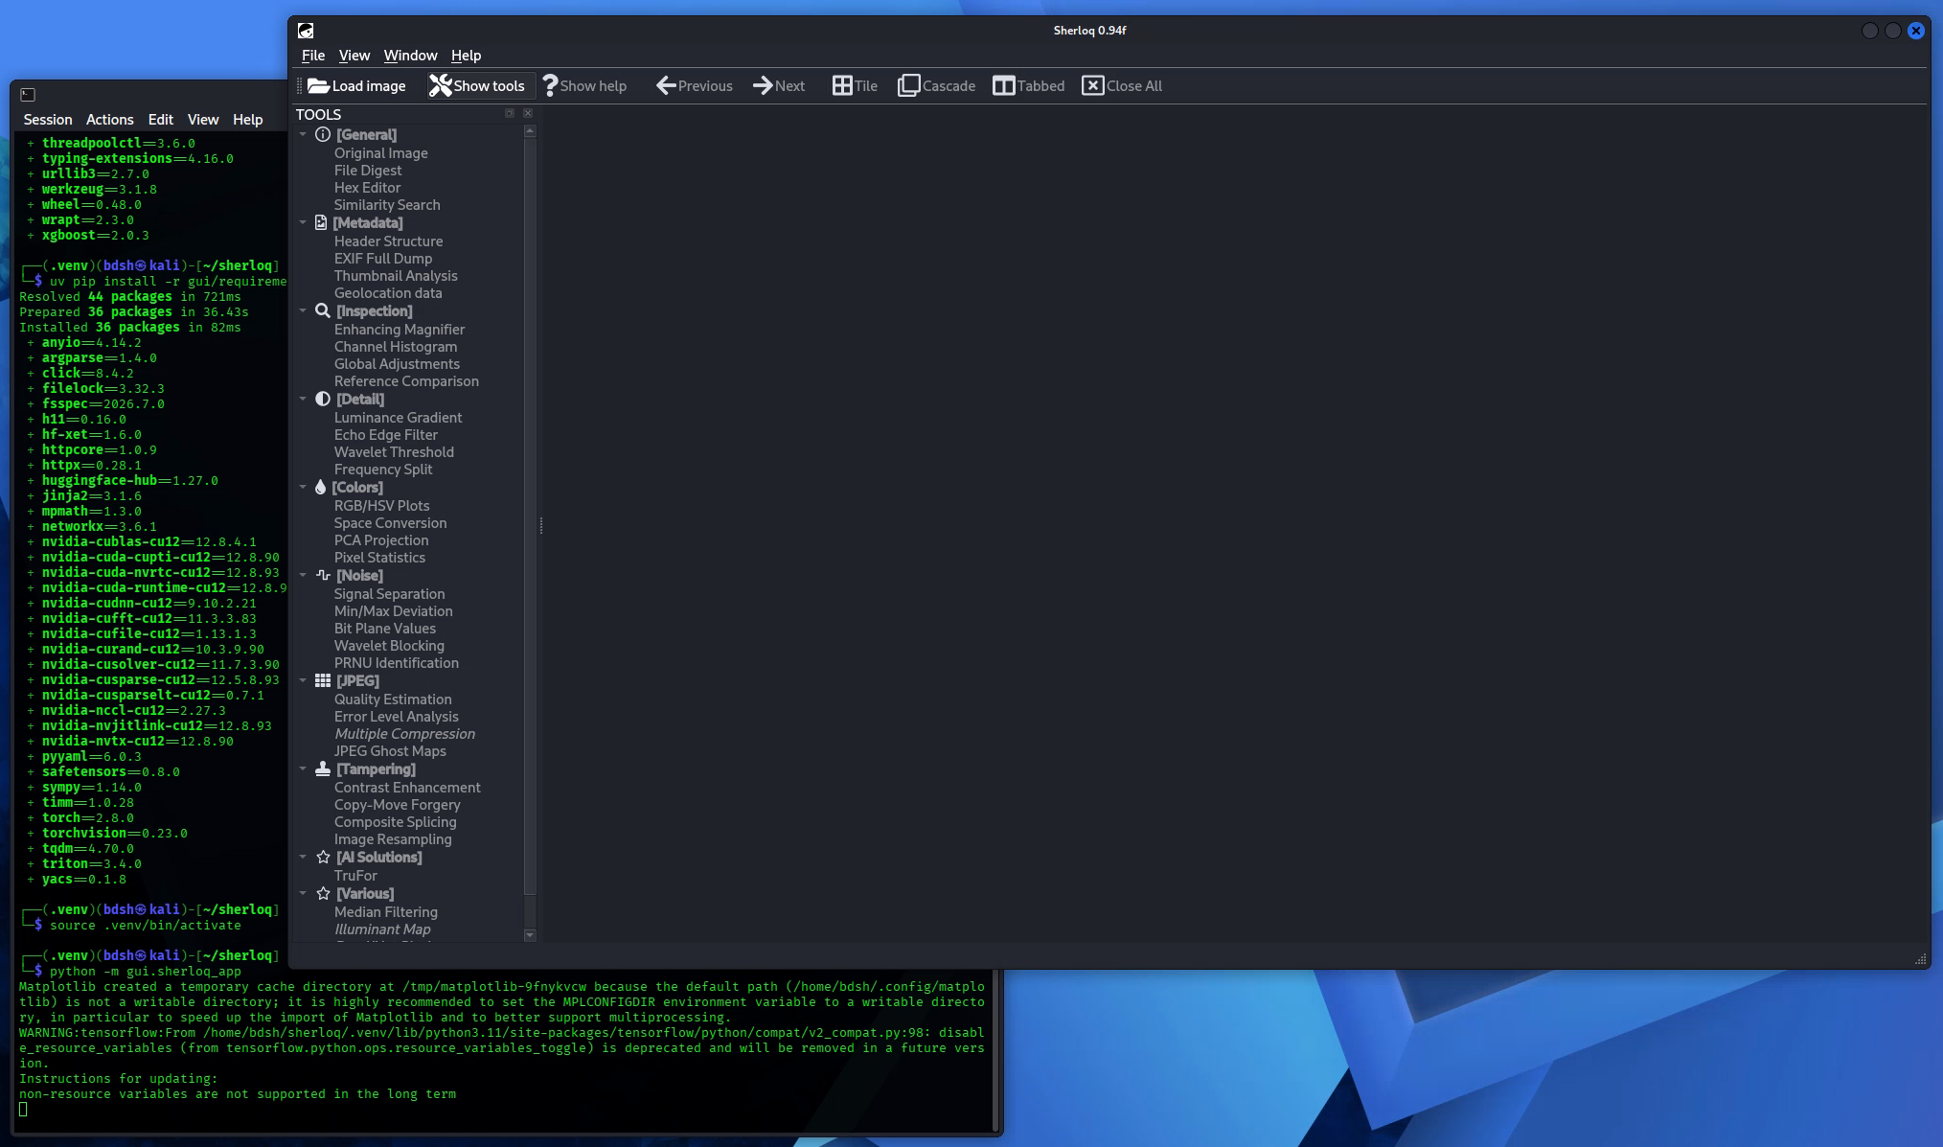
The weights required to complete the installation of the “TruFor” image manipulation detection AI model are not hosted on the github as they are said to be. However, the traditional features of Sherloq such as metadata extraction work.
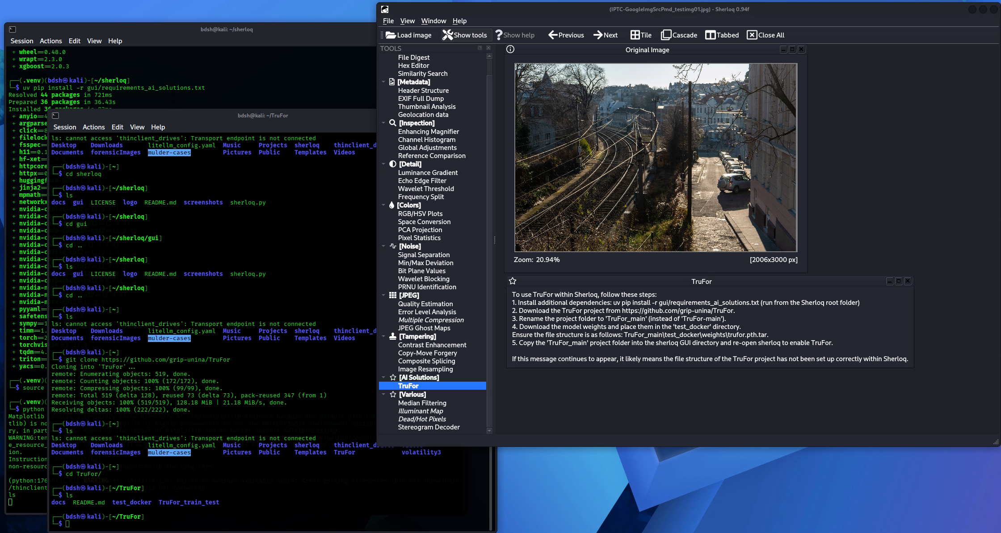
4:00-7:15PM (3hrs 15min)
Tried to install a couple of password cracking tools with AI augmentation.
Got “PassLLM” installed and working from within the python virtual environment, weights loaded successfully, this is running on localhost via webui.
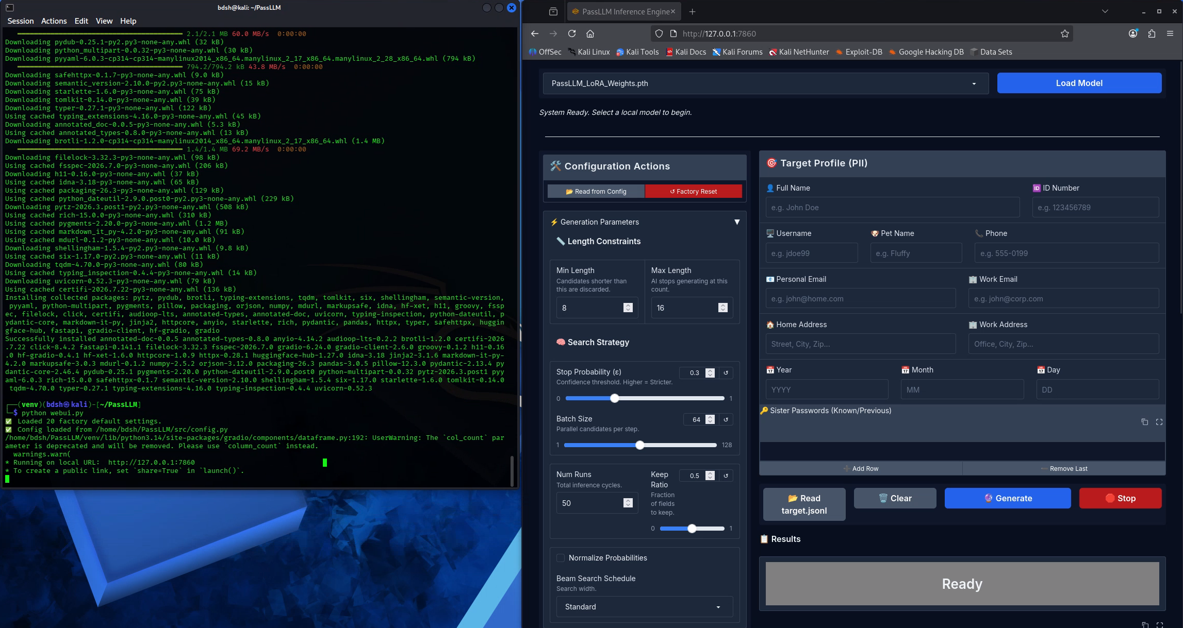
Attempting to generate potential password candidates failed because of missing dependencies
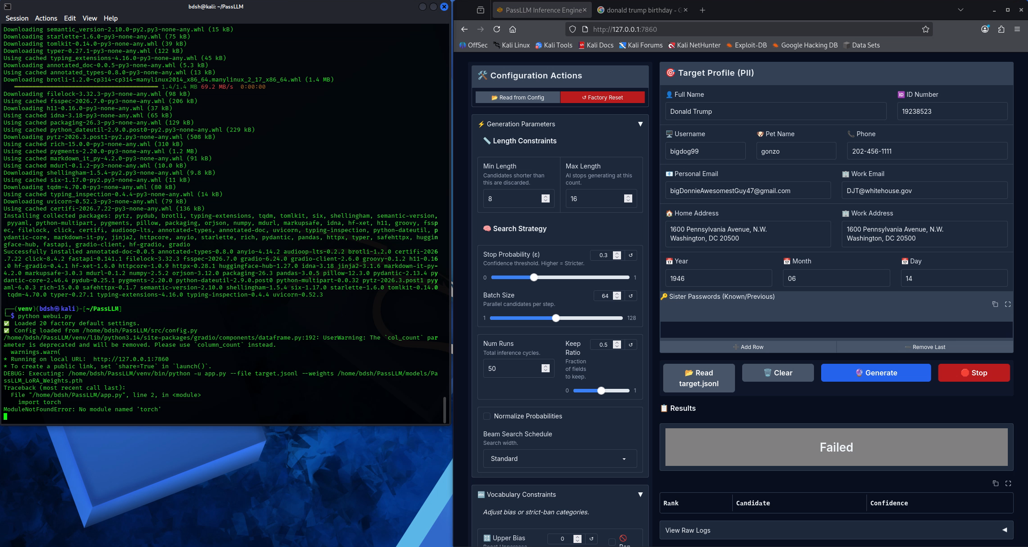
Installed all missing dependencies (3) and attempted again but failed, installed a version of “transformers” manually <5.0.0 as the documentation specifies and it appears to work, most likely password for Donald Trump based on the tool is “president”
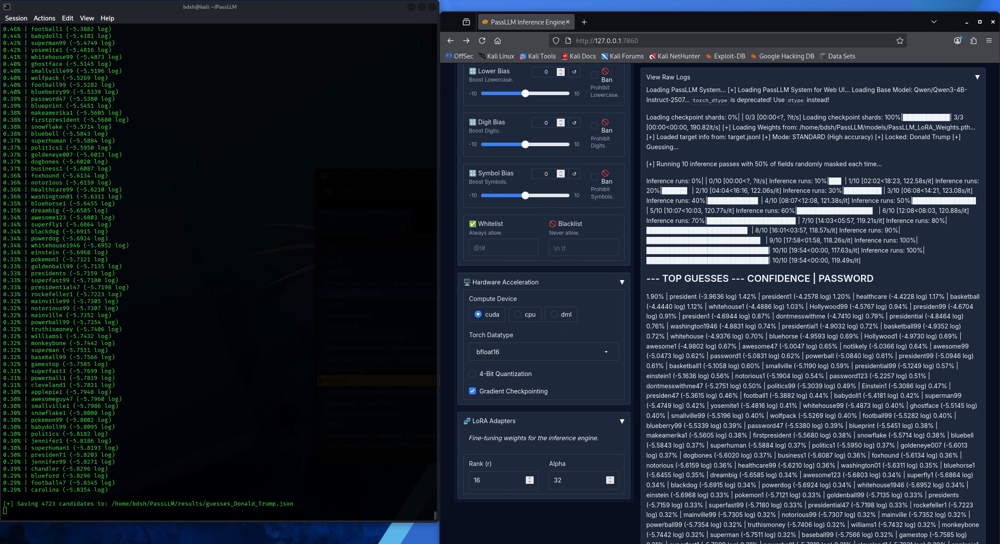

Development

